Free Pattern for Crochet Shawl for Tyler, Brenda or Gene
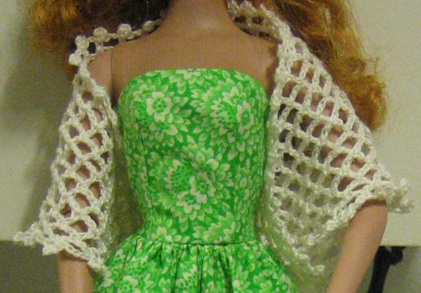
Using hook size B and bedspread cotton (size 10)
Note: dtc means yo 3 times
1. ch 7, dc in 1st ch, turn
2. ch 7, dc in dc, ch 2, skip 2 ch, dc in next ch, ch 2, dtc in same ch, turn
3. ch 7, *dc in dc, ch 2, rep from * 2 times, skip 2 ch, dc in next ch, ch 2, dtc in same ch, turn
Work like this rows 4-20
21. ch 7, in 5th ch from hook sl st, *dc in dc, ch3, sl st in dc, ch 2, repeat from * across
Edge along remaining two sides working in every loop, sc, ch 4, sl st in sc, ch 5
Do that twice at the point (Row 1)
Hope that came out right! Doing it was much easier than trying to write it down later :-)

